Artificial Intelligence for Testing and Calibration Laboratory Systems: A Structured Systematic Review and ISO/IEC 17025-Oriented Governance Framework
Article type: Review
Author information
Man Djun Lee1, Pui San Lee2
1Faculty of Mechanical Engineering, UiTM Johor Branch Pasir Gudang Campus, Jalan Purnama, 81750 Bandar Seri Alam, Masai, Malaysia
2Faculty of Civil Engineering, UMPSA, Universiti Malaysia, 26600 Pekan, Pahang, Malaysia
Corresponding author: leemandjun@uitm.edu.my
ORCID: https://orcid.org/0000-0002-1250-9459

Acknowledgements
Not applicable.

Abstract
Artificial intelligence (AI) is increasingly being explored for laboratory testing, calibration, data management, and decision support. For laboratories operating within ISO/IEC 17025-oriented quality systems, however, AI adoption raises specific questions about validation, metrological traceability, measurement uncertainty, data integrity, impartiality, and human accountability. This study is presented as a structured systematic review with thematic synthesis and ISO/IEC 17025 clause mapping. Thirty peer-reviewed studies were included in the qualitative evidence synthesis, while metrological, accreditation, and AI-governance documents were used as contextual sources for standards-oriented interpretation. The review shows that most available evidence comes from laboratory-adjacent settings such as clinical diagnostics, environmental sensor calibration, laboratory information systems, and AI governance, rather than from laboratories explicitly accredited to ISO/IEC 17025. The strongest technical evidence relates to analytical pattern recognition and sensor calibration, whereas direct evidence for accreditation governance, uncertainty treatment, and routine operational validation remains limited. The principal gap is the lack of standardized validation and governance frameworks for deploying AI in testing and calibration environments. The proposed framework therefore positions AI as a controlled support tool rather than an autonomous decision-maker and links each AI use case to documented validation, GUM-based uncertainty evaluation where applicable, traceability evidence, change control, audit trails, and authorized signatory review. The paper contributes a clause-by-clause mapping and an operational lifecycle for AI adoption in ISO/IEC 17025-oriented laboratory systems.
Keywords: artificial intelligence; ISO/IEC 17025; testing laboratories; calibration laboratories; metrology; measurement uncertainty; accreditation; explainable AI; quality assurance

1 Introduction
Artificial intelligence has become an important enabling technology in data-intensive scientific and engineering work. In laboratory contexts, AI may be used in at least three different ways. First, it can act as an analytical assistance tool, for example through pattern recognition, classification, anomaly detection, and signal or image interpretation. Second, it can be embedded within laboratory information or management systems to support technical record review, data validation, sample tracking, and trend analysis. Third, AI may be proposed for semi-autonomous or autonomous decision-making, such as classification of results, selection of methods, or generation of statements of conformity. These categories are not equivalent from a quality-management perspective because they carry different risks for validation, auditability, impartiality, and accountability [18-24].
ISO/IEC 17025:2017 specifies the general requirements for the competence, impartiality, and consistent operation of testing and calibration laboratories [3]. The standard does not prohibit the use of digital or AI-enabled tools. However, it requires laboratories to demonstrate the validity of results, metrological traceability, control of data and information management, competence of personnel, and appropriate actions to address risks and opportunities. When an AI model affects a test result, a calibration result, a technical record, a decision rule, or a report, the model becomes part of the laboratory process and should be controlled in the same disciplined way as equipment, software, methods, and technical records [3-12].
The available literature does not yet provide a large body of direct studies conducted inside laboratories explicitly accredited to ISO/IEC 17025. Instead, the evidence is distributed across related areas, including clinical laboratory medicine, environmental sensor calibration, automated experimental platforms, laboratory information systems, and trustworthy AI in metrology. This review therefore does not treat all included studies as direct accreditation evidence. Rather, it evaluates their transferability to ISO/IEC 17025-oriented laboratories by considering whether their methods and limitations are relevant to method verification or validation, uncertainty evaluation, traceability, technical records, decision-making, and quality governance.
The black-box nature of many AI models is particularly important for accredited laboratory systems. A result that cannot be explained, traced, reproduced, or validated may conflict with the logic of Clauses 7.2, 7.6, 7.7, 7.8, and 7.11 of ISO/IEC 17025. Explainable AI methods such as LIME, SHAP, and integrated gradients can provide model-attribution evidence, but they do not by themselves establish metrological traceability or measurement uncertainty. In calibration and quantitative testing, AI outputs should remain connected to a defined measurand, a validated measurement model, a traceability chain to SI units where applicable, and a documented uncertainty evaluation consistent with the GUM [4-6, 20-23, 25, 26].
This study therefore aims to: (i) identify AI applications relevant to testing, calibration, decision-making, data integrity, and laboratory quality management; (ii) classify the evidence by laboratory function, AI model type, validation maturity, and governance coverage; (iii) critically evaluate limitations related to transferability, uncertainty, traceability, explainability, and human accountability; and (iv) map AI applications to ISO/IEC 17025 requirements through a practical governance framework.

2 Methodology

2.1 Review design and scope
The article is a structured systematic review with thematic synthesis and ISO/IEC 17025 clause mapping. The review follows the PRISMA logic for transparent identification, screening, eligibility assessment, and inclusion [1]. Because direct AI evidence in ISO/IEC 17025-accredited laboratories is sparse, the review distinguishes between two evidence layers. The first layer consists of peer-reviewed studies included in the qualitative synthesis. The second layer consists of contextual and normative sources, including metrology guides, accreditation documents, and AI governance standards used to interpret the ISO/IEC 17025 implications of the synthesis.

2.2 Search strategy and sources
The database search covered publications from January 2017 to January 2026. A targeted supplementary search was then used to identify metrology and AI-governance guidance up to May 2026. The main databases were Scopus, Web of Science Core Collection, PubMed/MEDLINE, IEEE Xplore, ScienceDirect, and SpringerLink. Search strings were adapted to the syntax of each database. Table 1 provides the core reproducible strategy.
Table 1 Core search strategy and Boolean logic
Search component | Core search terms
Artificial intelligence block | "artificial intelligence" OR "machine learning" OR "deep learning" OR "explainable AI" OR XAI OR "predictive analytics"
Laboratory block | "testing laboratory" OR "calibration laboratory" OR "laboratory information management system" OR LIMS OR "clinical laboratory" OR "environmental monitoring" OR "sensor calibration"
ISO/quality block | "ISO/IEC 17025" OR accreditation OR "method validation" OR verification OR "measurement uncertainty" OR traceability OR "data integrity" OR "decision rule"
Combined query | (AI block) AND (laboratory block) AND (ISO/quality block)
Supplementary targeted query | "AI" AND metrology AND ("GUM" OR "measurement uncertainty" OR traceability OR "ISO/IEC 42001" OR "ISO/IEC 23894")

2.3 Eligibility criteria
Studies were included when they were peer-reviewed journal articles or peer-reviewed scholarly book chapters published in English from 2017 onward and addressed AI applications in laboratory, laboratory-like, metrological, data-management, or decision-support contexts relevant to testing, calibration, result interpretation, or quality management. Studies were excluded when they were preprints only, conference abstracts without full text, not related to laboratory processes, focused solely on clinical treatment without laboratory workflow relevance, or lacked sufficient methodological detail. Sources with unverified or unsuitable bibliographic status were excluded from the included corpus and were retained only when appropriate as contextual background; no preprint-only source was counted as an included study.

2.4 Screening, extraction and coding
Two reviewers screened titles and abstracts independently. Full texts were then assessed by consensus. Disagreements were resolved through discussion against the inclusion criteria. Extracted variables included author, year, domain, laboratory environment, AI method, dataset description, validation method, explainability approach, uncertainty treatment, traceability relevance, data-integrity controls, and ISO/IEC 17025 clause relevance. A standardized extraction sheet was used to reduce coding drift. For studies outside ISO/IEC 17025-accredited environments, transferability was coded separately so that indirect evidence was not overstated.

2.5 Quality and maturity assessment
A formal quality and maturity assessment was added because a vague fit-for-purpose assessment is insufficient for a structured systematic review. Each included study was scored across five criteria: dataset transparency, validation rigor, external validation or reproducibility, explainability or interpretability, and uncertainty/traceability/governance treatment. Each criterion was scored 0 = not addressed, 1 = partially addressed, or 2 = substantially addressed. Total scores ranged from 0 to 10 and were interpreted as low (0-3), moderate (4-6), or high (7-10). This tool was selected because the included studies span heterogeneous laboratory, metrological, clinical, and governance contexts, making a single clinical evidence-grading tool inappropriate for all sources.
Table 2 Quality and maturity scoring rubric
Criterion | Meaning | Scoring
Dataset transparency | Data source, preprocessing, and representativeness are described. | 0 = absent; 1 = partial; 2 = clear and auditable
Validation rigor | Cross-validation, hold-out testing, stress testing, or acceptance criteria are reported. | 0 = absent; 1 = internal only; 2 = robust with predefined criteria
External validation/reproducibility | Independent data, multi-site data, code, workflow, or reproducible protocol is provided. | 0 = absent; 1 = partial; 2 = substantial
Explainability/interpretability | Model behavior is interpretable or supported by XAI evidence. | 0 = absent; 1 = limited; 2 = substantial
Uncertainty/traceability/governance | Uncertainty, traceability, bias, audit trail, lifecycle monitoring, or governance is treated explicitly. | 0 = absent; 1 = partial; 2 = substantial

2.6 Synthesis and clause mapping
The synthesis was conducted in three stages. First, studies were grouped into functional domains. Second, evidence strength and limitations were compared across validation, uncertainty, explainability, and deployment maturity. Third, the findings were mapped to ISO/IEC 17025 clauses and supplemented by metrological and accreditation guidance. This produced an ISO/IEC 17025-oriented implementation framework rather than a claim that the reviewed studies themselves prove compliance.

Fig. 1 PRISMA flow diagram for the review corpus
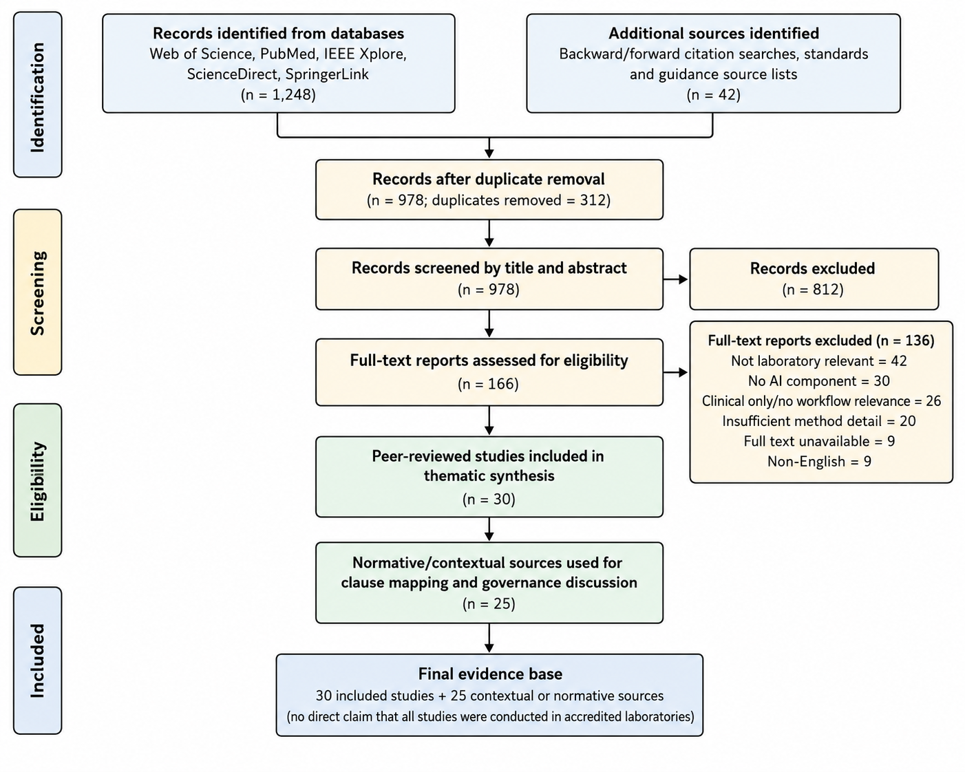

3 Results and discussion

3.1 Overview of included studies
The qualitative synthesis includes 30 peer-reviewed studies. Contextual, methodological, and normative documents were used only to support standards-oriented interpretation and were not counted as included studies. Table 3 and Table A1 apply the same five-domain classification to all 30 studies: testing and analysis (n = 7), calibration and metrology (n = 9), decision-making and interpretation (n = 5), data integrity and LIMS (n = 3), and governance and validation (n = 6).
None of the included studies documented a full AI implementation explicitly assessed within an ISO/IEC 17025-accredited testing or calibration laboratory. This absence is treated both as a limitation and as an important finding. The evidence is therefore interpreted as transferable evidence from adjacent laboratory and metrology contexts rather than as direct proof of accreditation compliance.
Table 3 Classification of included studies by domain, model type and governance maturity
Domain | n | Representative AI methods | Laboratory environment | Validation maturity | XAI/uncertainty status | Refs.
Testing and analysis | 7 | CNNs, classifiers, anomaly detection, NLP, diagnostic AI | Clinical diagnostics, non-clinical laboratories, automated HPLC | Mostly internal validation; limited external transferability | Generally limited; XAI rarely connected to audit evidence | [29-35]
Calibration and metrology | 9 | Regression, drift compensation, sensor calibration, uncertainty propagation, trustworthy AI | Environmental sensors, flow measurement, online calibration, and metrology | Moderate to high; includes field data, performance evaluation, and analytical UQ | Best quantitative UQ coverage, but traceability remains incomplete in many empirical studies | [25, 26, 38-44]
Decision-making and interpretation | 5 | Hybrid ML, AI-human comparison, black-box analysis, explanation frameworks | Laboratory experiments, collaborative experiments, radiology, healthcare, and oncology | Mostly conceptual, comparative, or internally evaluated | XAI discussed but not usually operationalized for ISO/IEC 17025 | [36, 37, 52-54]
Data integrity and LIMS | 3 | LIMS 4.0, FAIR data, automated data checks, responsible data governance | Laboratory medicine, commercial electrical/electronic laboratories, materials science | Moderate but mostly system-level | Audit trail and data provenance discussed more than model validation | [45-47]
Governance and validation | 6 | Readiness models, validation guidance, bias analysis, lifecycle governance | University and testing laboratories, clinical laboratories, and medical AI | Strong guidance value; limited direct accredited-laboratory deployment | Strongest coverage of lifecycle monitoring, bias, and governance controls | [27, 28, 48-51]
Fig. 2 Distribution of included studies by primary laboratory function
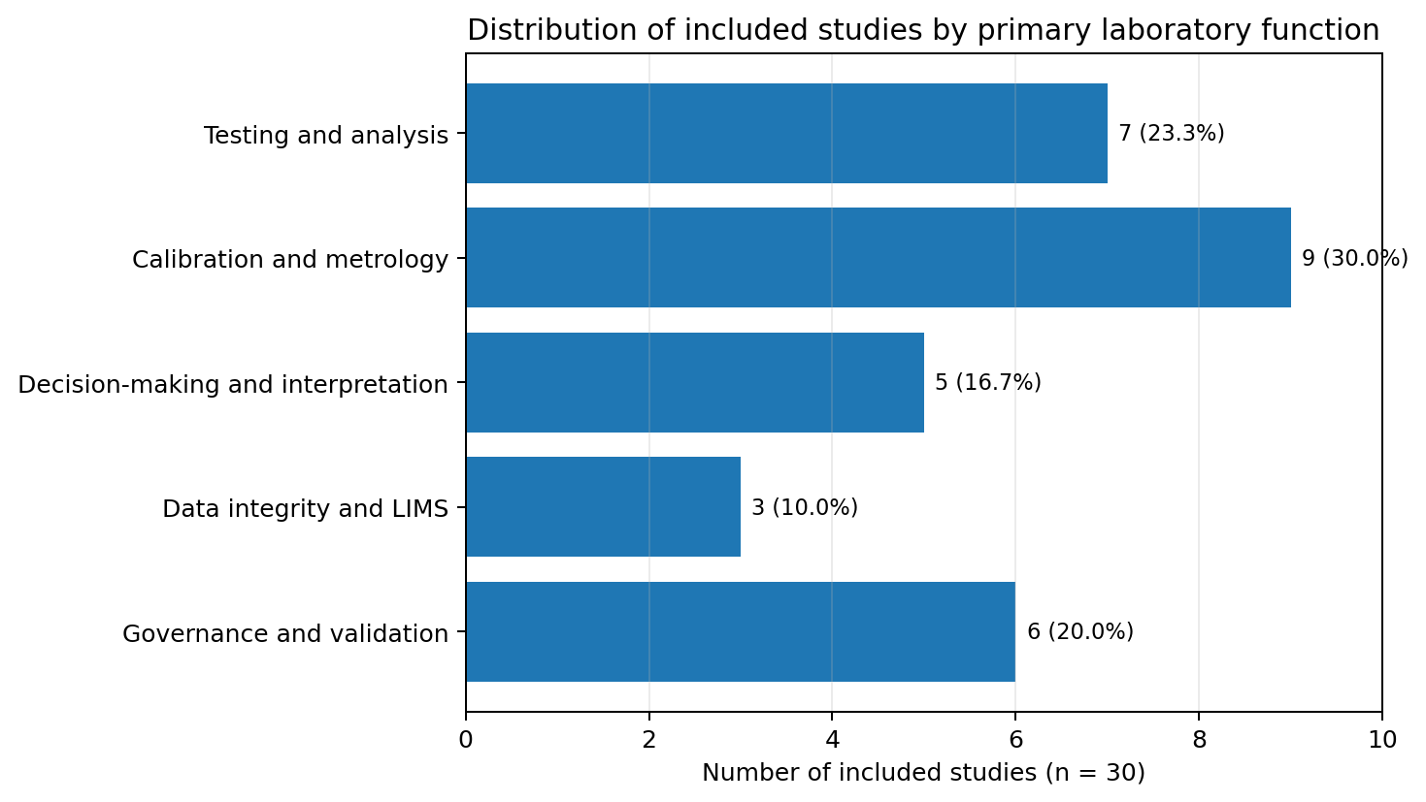

3.2 Quality and maturity profile
The quality assessment confirms that the evidence base is uneven. Studies on calibration and validation guidance generally provide more explicit performance or governance criteria than broad AI reviews. However, even technically strong studies often do not connect model validation to metrological traceability, a GUM-compliant uncertainty budget, or authorized signatory responsibility. The review therefore supports cautious integration rather than rapid autonomous deployment.
Table 4 Quality and maturity summary
Quality/maturity category | Number of studies | Interpretation for this review
High quality or high governance maturity | 8 | Eight studies scored 7-10 and provided the strongest evidence on validation, calibration performance, uncertainty propagation, or trustworthy AI; none was a complete ISO/IEC 17025 implementation.
Moderate quality or governance maturity | 22 | Twenty-two studies scored 4-6 and reported useful methods or governance considerations but lacked one or more elements such as external validation, XAI audit evidence, uncertainty linkage, or accredited-laboratory deployment.
Low quality or governance maturity | 0 | No included study scored within the predefined low category of 0-3.
Direct evidence in ISO/IEC 17025-accredited laboratories | 0 | No included study documented full deployment, validation, and accreditation assessment inside an ISO/IEC 17025-accredited laboratory.

3.3 Evidence by functional domain

3.3.1 AI in testing and analytical processes
Testing and analytical applications remain the largest domain. AI is most often used for classification, pattern recognition, anomaly detection, or automated interpretation of complex signals and images. Studies in diagnostics and automated HPLC demonstrate that AI can detect patterns and flag anomalies efficiently [29-35]. However, the evidence cannot be transferred directly to ISO/IEC 17025 compliance unless the model is incorporated into a verified or validated method, its intended use is specified, and performance is demonstrated under the laboratory's actual conditions. General claims that AI improves accuracy were therefore moderated in the synthesis. The stronger conclusion is that AI can support analytical consistency when its training data, validation limits, and decision thresholds are controlled.
Operationally, validation should be stratified by use case. An AI model that only flags records for human review can be validated against sensitivity, specificity, false-alert rate, and reviewer workload, whereas a model that directly contributes to a reported result requires method-level evidence for precision, bias, robustness, range, and decision thresholds. The validation dataset should represent the laboratory's instruments, matrices, operators, and environmental conditions, with predefined acceptance criteria and periodic re-evaluation when the data distribution or software version changes [3, 24, 29-35, 48, 49].

3.3.2 AI in calibration and metrology
Calibration and metrology are central to ISO/IEC 17025 because calibration results must remain traceable and uncertainty must be evaluated. Machine-learning calibration studies show potential for sensor drift correction, nonlinear error compensation, and field calibration of low-cost sensors [38-44]. Nevertheless, an AI correction model is not a traceability chain by itself. A laboratory should define the measurand, identify the input quantities, retain traceability evidence for reference standards or certified reference materials, validate the AI correction over the stated range, and include model-related uncertainty contributions in the uncertainty budget [4-12, 25, 26].
For a quantitative AI-assisted calibration model, the laboratory can treat the model output as part of the measurement model, for example y = f_AI(x, theta) + epsilon, where x represents traceable input quantities, theta represents the trained model parameters, and epsilon represents residual error. The combined standard uncertainty should include contributions from reference standards, repeatability, environmental effects, model residuals, training-data limitations, and model drift. AI drift should be monitored analogously to physical instrument drift through control charts, check standards, CRMs, proficiency testing or interlaboratory comparison results, and defined revalidation triggers.

3.3.3 AI in decision-making and result interpretation
Decision-support applications require careful distinction between interpretable models, post-hoc explanations, and opaque black-box systems. Interpretable models, such as simple regression or rule-based models, can be easier to audit because the decision logic is visible. Post-hoc methods such as LIME, SHAP, and integrated gradients can explain local or feature-level contributions but may not prove that the original model is reliable under all laboratory conditions [20-23]. For ISO/IEC 17025, XAI outputs should be treated as supporting evidence for review, not as substitutes for method validation, uncertainty evaluation, or authorized approval.
For laboratory deployment, explanation quality should be assessed against the needs of the technical reviewer rather than treated as a generic visualization. The laboratory should document which features influenced the output, whether explanations are stable for similar inputs, and how conflicts between AI output and conventional technical evidence are resolved. Critical decisions should default to human review, and disagreement cases should be retained as validation and training records [3, 20-24, 48-50, 52-54].

3.3.4 AI in data integrity and LIMS
AI-enabled LIMS and data-governance applications can support data validation, record retrieval, sample tracking, and audit preparation [45-47]. These applications align most closely with ISO/IEC 17025 requirements for technical records, control of data, and information management. However, AI tools in this domain also introduce cybersecurity, access-control, data-provenance, and audit-trail risks. The laboratory should therefore maintain version control, immutable audit trails, backup, access authorization, validated data transformations, and documented controls for model retraining or software updates.
A risk-based distinction is needed between AI that retrieves or summarizes existing records and AI that transforms, imputes, or generates technical data. Retrieval applications mainly require access control, completeness, and provenance checks; transformation or generation applications additionally require validation of calculations, preservation of original data, and controls that prevent silent overwriting. These controls should be tested during software updates and included in internal audits and management review [3, 13, 14, 45-47].

3.3.5 AI governance, validation and risk management
The governance literature emphasizes validation before deployment, continuous monitoring, bias detection, and human oversight [25-28, 48-54]. It also shows that AI performance can degrade when data distributions change or when models are moved to new sites, instruments, sample types, or populations [24, 48-50]. The interpretation is therefore intentionally conservative. AI should be controlled as software, method support, and risk-bearing process infrastructure. Its use should be justified through documented intended use, validation evidence, limitations, monitoring rules, change control, and signatory approval.
Governance maturity also depends on clear release criteria. Before deployment, the laboratory should define the model owner, approved version, intended users, prohibited uses, monitoring metrics, alert limits, retraining rules, and rollback procedure. Evidence of performance deterioration, bias, unexplained output, or failed quality-control checks should trigger documented restriction, suspension, or revalidation of the AI function [3, 13, 14, 24, 48-51].

3.4 Heterogeneity and strength of evidence
The included studies are heterogeneous in domain, model type, dataset quality, validation depth, and deployment context. Testing studies often report high algorithmic performance but provide limited evidence of cross-laboratory transferability. Calibration studies are more directly connected to measurement but often stop short of a full GUM uncertainty budget or traceability statement. Governance studies provide strong conceptual safeguards but limited empirical validation. This heterogeneity means that the review supports a risk-based implementation framework rather than a universal conclusion that AI is ready for autonomous use in accredited laboratories.
Accordingly, evidence strength was judged by relevance to the laboratory function and by the completeness of validation and governance controls, not by reported algorithmic accuracy alone. A high area-under-curve value or low prediction error may demonstrate technical performance on a particular dataset, but it does not establish robustness across instruments, sites, matrices, or time. The framework therefore treats external validation, traceability, uncertainty, auditability, and human authorization as separate evidence requirements.

3.5 Main research gap
The principal research gap is the absence of standardized validation and governance frameworks for AI deployment in testing and calibration environments. Existing studies rarely combine AI performance assessment with ISO/IEC 17025 requirements, GUM-based uncertainty evaluation, metrological traceability, data integrity, decision rules, and authorized signatory accountability. This gap justifies the clause mapping and lifecycle framework developed in the following section.
Future work should convert this gap into testable research questions. Priority studies include multi-laboratory validation of AI-assisted methods, estimation of model-related uncertainty components, comparison of AI drift indicators with conventional check-standard data, and assessor-led evaluation of the proposed evidence package. Such studies would allow the framework to move from standards-oriented synthesis to empirically supported implementation guidance.

4 ISO/IEC 17025-oriented AI governance framework

4.1 Clause-by-clause mapping
Table 5 maps AI use cases to specific ISO/IEC 17025 controls, evidence records, and supporting references. The mapping clarifies that confidentiality, traceability, uncertainty, verification, validation, and calibration-interval decisions require documented technical and governance controls beyond generic human supervision.
Table 5 ISO/IEC 17025 clause-by-clause AI mapping
Clause | Potential AI use | Key risk | Required control/evidence | Refs.
4.1 Impartiality | AI-assisted prioritization, classification or anomaly flagging | Biased training data may influence outcomes | Bias assessment, independent technical review, locked model version, documented impartiality risk entry | [3, 14, 24, 49, 50]
4.2 Confidentiality | AI tools handling customer data, prompts, records or reports | Leakage of customer information to external systems | Data-processing agreement, access control, local/approved hosting, prompt logging policy, masking of confidential identifiers | [3, 13-17]
5.1-5.2 Legal and structural responsibility | AI embedded in the laboratory process | Unclear accountability | Define process owner, quality owner, technical approver, and authorized signatory accountability | [3, 13, 14]
5.3-5.7 Authority and responsibilities | AI-supported workflow allocation or report drafting | Responsibility gaps when AI influences actions | Authority matrix, approval workflow, competency records, segregation of duties | [3, 27, 28]
6.2 Personnel | AI training assistant or decision-support dashboard | Staff may rely on AI without competence | Training, authorization before use, competency checks, records of limitations and escalation | [3, 48, 49]
6.3 Facilities/environment | AI monitoring of temperature, humidity or environmental trends | False alarms or missed excursions | Calibrated sensors, alert validation, control limits, manual confirmation of critical excursions | [3, 7, 8]
6.4 Equipment | Predictive maintenance and calibration interval optimization | Unsupported interval changes could affect scope or validity | Check standards, maintenance verification, documented interval review, accreditation-body consultation where scope/CMC may be affected | [3, 7-10, 38-44]
6.5 Metrological traceability | AI-supported traceability review or calibration correction | AI may infer traceability without evidence | Traceability chain to SI or accepted reference, reference-standard certificates, CRM records, human verification | [3, 4, 6, 7, 25, 26]
6.6 Externally provided products/services | AI vendor scoring or cloud AI service | Opaque supplier risk scoring | Supplier evaluation criteria, cybersecurity review, service-level agreement, change notification requirement | [3, 13, 14]
7.1 Review of requests/contracts | NLP review of customer specifications | Misinterpretation of requirements or decision rules | Human confirmation of requirements, agreed decision rule, record of AI recommendation and final reviewer | [3, 9, 12]
7.2.1 Method verification | AI used with a standard method without modification | Method may not perform as expected in the laboratory | Verify AI-assisted method under local conditions with predefined acceptance criteria | [3, 48, 49]
7.2.2 Method validation | AI-created or AI-modified method | Unvalidated model changes can alter the measurand/result | Full validation including range, robustness, bias, precision, uncertainty, XAI evidence where applicable | [3, 4, 25, 26, 48, 49]
7.3 Sampling | AI risk-based sampling recommendations | Historical data may introduce sampling bias | Approved sampling plan, statistical justification, periodic bias review | [3, 14, 49, 50]
7.4 Handling of items | AI image checks or sample identification | Misidentification of samples | Barcode/RFID confirmation, chain-of-custody record, manual escalation for mismatch | [3, 45-47]
7.5 Technical records | AI extraction, summarization or anomaly flagging | Record alteration or context loss | Immutable audit trail, version control, reviewer identity, original record retention | [3, 45-47]
7.6 Measurement uncertainty | AI uncertainty modelling or correction factors | Hidden assumptions or unquantified model error | GUM-based uncertainty budget including model residuals, training-data limits, drift, and reference-standard uncertainty | [4, 5, 8, 11, 12, 25, 26]
7.7 Ensuring validity of results | QC trend analysis, outlier detection, PT/ILC analytics | False positive or false negative QC decisions | Control charts, adversarial/stress testing, PT/ILC comparison, revalidation triggers | [3, 9, 38-44, 48, 49]
7.8 Reporting of results | AI-assisted draft reports or conformity statements | Unsupported statements or wrong decision rule | Authorized signatory review, approved templates, decision-rule record, no autonomous release | [3, 9, 12]
7.9 Complaints | NLP classification of complaints | Severity misclassification | Escalation criteria, human review, trend analysis, management review | [3, 13, 14]
7.10 Nonconforming work | AI alerts for abnormal trends | Overtriggering or missed critical cases | Investigation workflow, evidence retention, CAPA linkage, model-performance review | [3, 48, 49]
7.11 Data and information management | AI-integrated LIMS and dashboards | Cybersecurity, opaque transformation, model drift | Validation, access controls, backup, audit trails, change management, retraining approval | [3, 13, 45-47]
8.1-8.4 Management system documents and records | AI document retrieval, clause tagging, version comparison | Wrong tagging or unauthorized edits | Controlled document workflow, restricted editing, review by quality manager, audit logs | [3, 13, 14]
8.5 Risks and opportunities | AI risk scoring | Overreliance on model outputs | AI risk register, defined acceptance criteria, management review | [3, 13, 14]
8.6 Improvement | Pattern detection in recurring quality issues | Weak correlations may drive poor actions | Root-cause verification before action, evidence-based improvement plan | [3, 48, 49]
8.7 Corrective action | AI clustering of causes or CAPA prioritization | Wrong causal inference | Human-led cause verification, documented rationale, effectiveness review | [3, 48, 49]
8.8 Internal audits | AI-assisted checklist generation and evidence mining | Audit bias if AI searches only common issues | Auditor sampling plan, balanced clause coverage, independent judgement | [3, 13, 14]
8.9 Management review | AI dashboards and KPI summaries | Oversimplified or unverified conclusions | Management interpretation, raw-data drilldown, evidence review, action tracking | [3, 13, 14]

4.2 Integration framework
The framework is a lifecycle rather than a static hierarchy. It starts with use-case selection and intended-use definition, proceeds through data and model control, verification or validation, approval for use, operational monitoring, and management review, and then feeds back into change control and revalidation. This cyclical design better reflects the continual-improvement logic of ISO/IEC 17025 and avoids presenting the framework as already validated for compliance.
Each lifecycle transition should have an explicit gate. A model should not move from development to routine use until data suitability, method verification or validation, uncertainty and traceability implications, cybersecurity, and user competence have been reviewed. Likewise, retraining, parameter changes, vendor updates, or changes in intended use should return the system to impact assessment and, when necessary, partial or full revalidation.
Fig. 3 AI-ISO/IEC 17025 lifecycle framework with feedback and change control
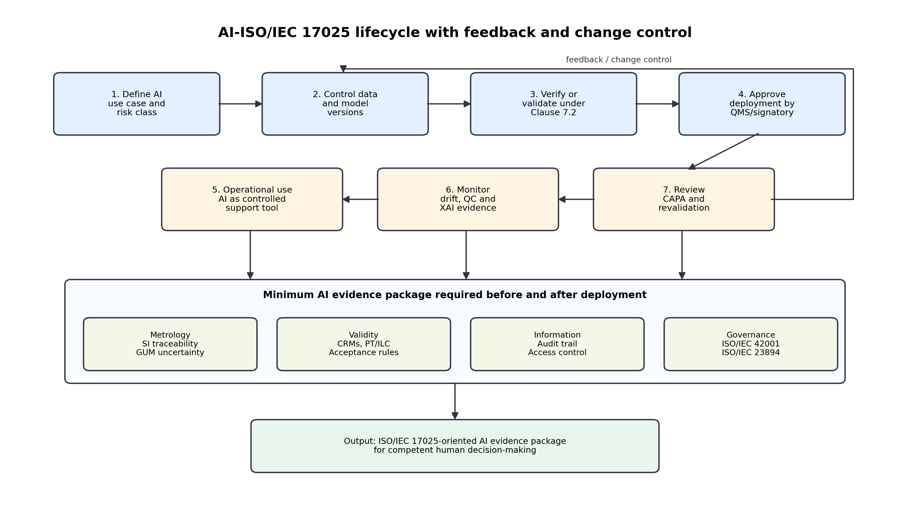

4.3 Operational implementation workflow
Table 6 Operational workflow for AI implementation in ISO/IEC 17025-oriented laboratories
Stage | Main action | Minimum evidence record
1. Define intended use | State whether AI supports testing, calibration, data management, decision support, or reporting. | AI use-case form, risk classification, affected clauses
2. Establish data controls | Define data provenance, representativeness, preprocessing, access rights, and retention. | Dataset register, data lineage, access log
3. Select model and XAI approach | Prefer transparent models when possible; justify black-box models; select SHAP, LIME, integrated gradients or other explainability methods when appropriate. | Model selection rationale, XAI report
4. Verify or validate | Apply Clause 7.2.1 verification for standard methods and Clause 7.2.2 validation for non-standard or modified methods. | Validation protocol, acceptance criteria, performance report
5. Evaluate uncertainty and traceability | For quantitative outputs, include model residuals, drift and data limitations in the uncertainty budget. | GUM uncertainty budget, traceability evidence
6. Approve deployment | Require quality and technical approval before routine use. | Approval record, authorized users, release version
7. Monitor performance | Track drift, false alerts, QC failures, PT/ILC results, complaints and nonconforming work. | Monitoring dashboard, control charts, deviation records
8. Control changes | Retraining, parameter changes, software updates or scope changes trigger review and possible revalidation. | Change request, impact assessment, revalidation record
9. Management review | Review AI risks, benefits, failures, CAPA and improvement opportunities. | Management review minutes, action plan

4.4 Authorized signatory accountability
AI cannot act as a legal or technical signatory for laboratory results. Even when AI contributes to result interpretation, report drafting, or conformity assessment, the authorized signatory remains responsible for reviewing the evidence, confirming that the decision rule is appropriate, and ensuring that reported results are valid. The quality management system should therefore bridge algorithmic output and human responsibility through approval workflows, documented review, role-based authorization, and escalation rules. No AI-generated report, conformity statement, or calibration conclusion should be released without competent human authorization.
To make this accountability auditable, the report or technical record should identify the AI-supported step, the model and version used, the reviewer, the evidence considered, and any override of the model output. Where the AI output is material to a conformity decision, the signatory should be able to reconstruct the decision from retained records without relying on inaccessible vendor logic.

4.5 Relationship with AI governance standards
ISO/IEC 17025 provides the laboratory competence and result-validity framework, but it does not contain detailed AI lifecycle requirements. ISO/IEC 42001 and ISO/IEC 23894 can therefore be used as complementary governance references for AI management systems and AI risk management. The EU AI Act, FDA draft lifecycle guidance for AI/ML-enabled medical devices, and the Walbrook AI QI Accord further reinforce lifecycle control, risk-based assurance, documentation, monitoring, and human oversight [13-17]. These instruments should not replace ISO/IEC 17025 requirements; rather, they can help laboratories define the evidence package needed to make AI auditable.
These complementary documents serve different purposes and should be applied proportionately. ISO/IEC 42001 supports organization-level AI management, ISO/IEC 23894 supports risk identification and treatment, the EU AI Act establishes legal obligations for defined AI uses, and the FDA document provides draft lifecycle recommendations in a regulated medical-device context. For an ISO/IEC 17025 laboratory, their value lies in strengthening documented controls while the competence, traceability, and validity requirements remain anchored in ISO/IEC 17025.

5 Limitations and future work
This review has four main limitations. No included study documented a complete AI implementation within an explicitly ISO/IEC 17025-accredited testing or calibration laboratory. Therefore, the proposed framework should be regarded as ISO/IEC 17025-oriented and still requires future empirical validation. The evidence base is also heterogeneous, as many studies were drawn from adjacent contexts, including clinical laboratories, sensor calibration, LIMS, and AI-governance literature.
Although a quality scoring rubric was introduced, the scores are limited to the information available in published papers and cannot replace direct access to laboratory validation records. The framework has not yet been validated through a Delphi panel, accreditation-body review, or multi-laboratory case study. Future research should therefore test the framework using real laboratory use cases, expert review, proficiency-testing data, interlaboratory comparisons, and documented accreditation assessments.

6 Conclusions
This review clarifies that the available evidence on AI for ISO/IEC 17025-oriented laboratories remains promising but indirect. The evidence synthesis includes 30 peer-reviewed studies and separates these from contextual and normative references. AI shows clear potential in analytical assistance, anomaly detection, calibration correction, data management, and decision support. However, the main barriers are not only technical performance. The critical barriers are validation, metrological traceability, GUM-consistent uncertainty evaluation, explainability, data integrity, change control, and human accountability. The clause mapping and lifecycle framework provide a cautious and operational pathway for laboratories that wish to adopt AI without weakening ISO/IEC 17025 principles. AI should be implemented as a controlled support tool within the laboratory quality management system, with final responsibility retained by competent personnel and authorized signatories.

Statements and declarations

Funding
No funding was received for conducting this study.

Competing interests
The authors have no competing interests to declare that are relevant to the content of this article.

Ethics approval
Not applicable. This article does not contain any studies with human participants or animals performed by the authors.

Consent to participate
Not applicable.

Data availability
This review is based on published literature. The evidence table in Appendix A lists the included studies, primary domain, quality score and DOI/status. The extraction sheet, search strings, quality scoring sheet and figure data can be made available by the corresponding author upon reasonable request.

Author contributions
Man Djun Lee: conceptualization, methodology, literature search, screening, data extraction, quality assessment, framework development, writing - original draft, and writing - review and editing. Pui San Lee: screening verification, data extraction checking, quality scoring verification, table development, and writing - review and editing.

Appendix A Included studies and quality assessment
The table lists the 30 studies retained in the qualitative synthesis. Contextual, methodological and normative sources are cited in the reference list but are not counted as included studies.
Table A1 Included studies, domains and quality scores
ID | Study | Primary domain | Laboratory or evidence context | AI/model focus | Maturity | Score
S1 | Aqidawati et al. (2019) | Governance and validation | University testing laboratory; ISO/IEC 17025 readiness | Readiness model | Moderate | 4/10
S2 | Simoncic (2024) | Governance and validation | Testing laboratories; AI integration challenges | Conceptual/technical review | Moderate | 4/10
S3 | Zai et al. (2025) | Testing and analysis | Non-clinical laboratory documentation and good practices | AI/NLP support | Moderate | 5/10
S4 | Assudani et al. (2025) | Testing and analysis | Infectious disease diagnostic workflows | ML/DL review | Moderate | 5/10
S5 | Zhou et al. (2025) | Testing and analysis | Disease diagnosis technologies | ML/DL review | Moderate | 5/10
S6 | Ismayilzada (2026) | Testing and analysis | Acute appendicitis diagnostic evidence | AI systematic review | Moderate | 5/10
S7 | Najar Najafi et al. (2025) | Testing and analysis | Cancer diagnosis and treatment literature | AI review | Moderate | 4/10
S8 | Sabri et al. (2025) | Testing and analysis | Medical imaging diagnostics | ML/DL review | Moderate | 5/10
S9 | Gusev et al. (2025) | Testing and analysis | Automated HPLC cloud laboratory | Anomaly detection | High | 7/10
S10 | Campos Diocaretz et al. (2025) | Decision-making and interpretation | Laboratory experiments | Hybrid ML decision support | Moderate | 6/10
S11 | Wang et al. (2025) | Decision-making and interpretation | Collaborative experiments | Comparison of AI and human mechanisms | Moderate | 5/10
S12 | Chakravarthy et al. (2026) | Calibration and metrology | Electrochemical environmental monitoring networks | Drift compensation | Moderate | 6/10
S13 | Koziel et al. (2024a) | Calibration and metrology | Low-cost NO2 sensor calibration | ML calibration | High | 7/10
S14 | Koziel et al. (2024b) | Calibration and metrology | NO2 sensor calibration by time-series matching | ML calibration | High | 7/10
S15 | Pedro Santos et al. (2025) | Calibration and metrology | IoT air-quality sensors | ML calibration/performance evaluation | Moderate | 6/10
S16 | Yang et al. (2026) | Calibration and metrology | PID sensors for VOC OH reactivity | Short-term ML calibration | Moderate | 6/10
S17 | Patra et al. (2021) | Calibration and metrology | Low-cost particulate matter sensors | Field calibration with ML | High | 7/10
S18 | Zhu et al. (2024) | Calibration and metrology | Online calibration of flow measurement errors | ML error correction | Moderate | 6/10
S19 | Blatter et al. (2022) | Data integrity and LIMS | Laboratory medicine data quality | FAIR/AI data quality | Moderate | 6/10
S20 | Yuen et al. (2025) | Data integrity and LIMS | Commercial electrical/electronic laboratories | LIMS 4.0 model | Moderate | 6/10
S21 | Reeves-McLaren & Moth-Lund Christensen (2026) | Data integrity and LIMS | Materials science data integrity | Responsible AI/data governance | Moderate | 6/10
S22 | Spies et al. (2024) | Governance and validation | Clinical laboratory ML | Validation/implementation/monitoring | High | 8/10
S23 | Miller & Valdes (2025) | Governance and validation | Laboratory medicine ML | Validation guidance | High | 8/10
S24 | Cross et al. (2024) | Governance and validation | Medical AI bias | Bias analysis | Moderate | 6/10
S25 | Hanna et al. (2025) | Governance and validation | Pathology AI/ML | Ethics and bias | Moderate | 6/10
S26 | Marcus & Teuwen (2024) | Decision-making and interpretation | Radiology explanation | XAI conceptual analysis | Moderate | 6/10
S27 | Prince & Savulescu (2025) | Decision-making and interpretation | Healthcare black-box justification | Ethical analysis | Moderate | 6/10
S28 | Ferguson et al. (2020) | Decision-making and interpretation | Oncology AI | Black-box analysis | Moderate | 4/10
S29 | Thompson (2024) | Calibration and metrology | ML uncertainty propagation | GUM-based analytical UQ | High | 8/10
S30 | Adel et al. (2024) | Calibration and metrology | Trustworthy AI in metrology | TAI/UQ framework | High | 8/10

References
1. Page, M. J., McKenzie, J. E., Bossuyt, P. M., Boutron, I., Hoffmann, T. C., Mulrow, C. D., et al. (2021). The PRISMA 2020 statement: an updated guideline for reporting systematic reviews. BMJ, 372, n71. https://doi.org/10.1136/bmj.n71
2. Snyder, H. (2019). Literature review as a research methodology: an overview and guidelines. Journal of Business Research, 104, 333-339. https://doi.org/10.1016/j.jbusres.2019.07.039
3. International Organization for Standardization. (2017). ISO/IEC 17025:2017: general requirements for the competence of testing and calibration laboratories. ISO.
4. Joint Committee for Guides in Metrology. (2008). JCGM 100:2008: evaluation of measurement data - guide to the expression of uncertainty in measurement. BIPM.
5. Joint Committee for Guides in Metrology. (2023). JCGM GUM-1:2023: guide to the expression of uncertainty in measurement - part 1: introduction. BIPM.
6. Joint Committee for Guides in Metrology. (2012). JCGM 200:2012: international vocabulary of metrology - basic and general concepts and associated terms (VIM) (3rd ed.). BIPM.
7. International Laboratory Accreditation Cooperation. (2020). ILAC-P10:07/2020: ILAC policy on metrological traceability of measurement results. ILAC.
8. International Laboratory Accreditation Cooperation. (2020). ILAC-P14:09/2020: ILAC policy for measurement uncertainty in calibration. ILAC.
9. International Laboratory Accreditation Cooperation. (2019). ILAC-G8:09/2019: guidelines on decision rules and statements of conformity. ILAC.
10. International Laboratory Accreditation Cooperation. (2024). ILAC-G18:01/2024: guideline for describing scopes of accreditation. ILAC.
11. Ellison, S. L. R., & Williams, A. (Eds.). (2012). Eurachem/CITAC guide: quantifying uncertainty in analytical measurement (3rd ed.). Eurachem.
12. Eurachem/CITAC. (2021). Use of uncertainty information in compliance assessment (2nd ed.). Eurachem.
13. International Organization for Standardization. (2023). ISO/IEC 42001:2023: information technology - artificial intelligence - management system. ISO.
14. International Organization for Standardization. (2023). ISO/IEC 23894:2023: information technology - artificial intelligence - guidance on risk management. ISO.
15. European Parliament and Council of the European Union. (2024). Regulation (EU) 2024/1689 laying down harmonised rules on artificial intelligence. Official Journal of the European Union.
16. U.S. Food and Drug Administration. (2025). Artificial intelligence-enabled device software functions: lifecycle management and marketing submission recommendations. Draft guidance for industry and Food and Drug Administration staff. FDA.
17. International Network on Quality Infrastructure. (2024). Walbrook AI QI Accord. ILAC, UKAS and TIC Council.
18. Topol, E. J. (2019). High-performance medicine: the convergence of human and artificial intelligence. Nature Medicine, 25(1), 44-56. https://doi.org/10.1038/s41591-018-0300-7
19. Esteva, A., Robicquet, A., Ramsundar, B., Kuleshov, V., DePristo, M., Chou, K., Cui, C., Corrado, G., Thrun, S., & Dean, J. (2019). A guide to deep learning in healthcare. Nature Medicine, 25(1), 24-29. https://doi.org/10.1038/s41591-018-0316-z
20. Samek, W., Wiegand, T., & Muller, K. R. (2017). Explainable artificial intelligence: understanding, visualizing and interpreting deep learning models. IEEE Signal Processing Magazine, 34(6), 56-65. https://doi.org/10.1109/MSP.2017.2740961
21. Ribeiro, M. T., Singh, S., & Guestrin, C. (2016). "Why should I trust you?": explaining the predictions of any classifier. Proceedings of the 22nd ACM SIGKDD International Conference on Knowledge Discovery and Data Mining, 1135-1144. https://doi.org/10.1145/2939672.2939778
22. Lundberg, S. M., & Lee, S. I. (2017). A unified approach to interpreting model predictions. Advances in Neural Information Processing Systems, 30, 4765-4774.
23. Sundararajan, M., Taly, A., & Yan, Q. (2017). Axiomatic attribution for deep networks. Proceedings of the 34th International Conference on Machine Learning, 3319-3328.
24. Kelly, C. J., Karthikesalingam, A., Suleyman, M., Corrado, G., & King, D. (2019). Key challenges for delivering clinical impact with artificial intelligence. BMC Medicine, 17, 195. https://doi.org/10.1186/s12916-019-1426-2
25. Thompson, A. (2024). Analytical results for uncertainty propagation through trained machine learning regression models. Measurement, 234, 114841. https://doi.org/10.1016/j.measurement.2024.114841
26. Adel, T., Bilson, S., Levene, M., & Thompson, A. (2024). Trustworthy artificial intelligence in the context of metrology. In Producing artificial intelligent systems (pp. 53-75). Springer. https://doi.org/10.1007/978-3-031-55817-7_4
27. Aqidawati, E. F., Sutopo, W., & Zakaria, R. (2019). Model to measure the readiness of university testing laboratories to fulfill ISO/IEC 17025 requirements: a case study. Journal of Open Innovation: Technology, Market, and Complexity, 5(1), 2. https://doi.org/10.3390/joitmc5010002
28. Simoncic, M. (2024). Challenges of integrating artificial intelligence into testing laboratories. Challenges of the Future, 9(3). https://doi.org/10.37886/ip.2024.008
29. Zai, K., Mukti, A. P., Notty, G. S., Niswah, S. U., Refliandi, & Oktivendra, F. (2025). Artificial intelligence in the non-clinical laboratory: enhancing good laboratory and documentation practices. International Journal of Pharmaceutics, 685, 126266. https://doi.org/10.1016/j.ijpharm.2025.126266
30. Assudani, P. J., Bhurgy, A. S., Kollem, S., Bhurgy, B. S., Ahmad, M. O., Kulkarni, M. B., & Bhaiyya, M. (2025). Artificial intelligence and machine learning in infectious disease diagnostics: a comprehensive review of applications, challenges, and future directions. Microchemical Journal, 218, 115802. https://doi.org/10.1016/j.microc.2025.115802
31. Zhou, J., Park, S., Dong, S., Tang, X., & Wei, X. (2025). Artificial intelligence-driven transformative applications in disease diagnosis technology. Medical Review, 5(5), 353-377. https://doi.org/10.1515/mr-2024-0097
32. Ismayilzada, K. (2026). Artificial intelligence for acute appendicitis diagnosis: a systematic review of current evidence, challenges, and future directions. Medicine, 105(12), e48094. https://doi.org/10.1097/MD.0000000000048094
33. Najar Najafi, N., Hajihassani, H., & Azimzadeh Irani, M. (2025). The impact of artificial intelligence on cancer diagnosis and treatment: a review. Cancer Informatics, 24, 11769351251371272. https://doi.org/10.1177/11769351251371273
34. Sabri, O., Al-Shargabi, B., & Abuarqoub, A. (2025). The role of artificial intelligence in improving diagnostic accuracy in medical imaging: a review. Computers, Materials and Continua, 85(2), 2443-2486. https://doi.org/10.32604/cmc.2025.066987
35. Gusev, F., Kline, B. C., Quinn, R., Xu, A., Smith, B., Frezza, B., & Isayev, O. (2025). Machine learning anomaly detection of automated HPLC experiments in the cloud laboratory. Digital Discovery, 4(12), 3445-3454. https://doi.org/10.1039/D5DD00253B
36. Campos Diocaretz, B., Tuzesi, A., & Herdean, A. (2025). A simple yet powerful hybrid machine learning approach to aid decision-making in laboratory experiments. Machine Learning and Knowledge Extraction, 7(3), 60. https://doi.org/10.3390/make7030060
37. Wang, L., Jiang, Z., Hu, C., Zhao, J., Zhu, Z., Chen, X., Wang, Z., Liu, T., He, G., Yin, Y., & Lee, D. H. (2025). Comparing AI and human decision-making mechanisms in daily collaborative experiments. iScience, 28(6), 112711. https://doi.org/10.1016/j.isci.2025.112711
38. Chakravarthy, V. J., Yasaswini, V., Sanguri, M., Balraj, S., Jency, S., & Anandhakrishnan, T. (2026). Machine learning-enhanced calibration algorithm for drift compensation in long-term electrochemical environmental monitoring networks. Analytical Letters. https://doi.org/10.1080/00032719.2026.2618976
39. Koziel, S., Pietrenko-Dabrowska, A., Wojcikowski, M., & Pankiewicz, B. (2024). High-performance machine-learning-based calibration of low-cost nitrogen dioxide sensor using environmental parameter differentials and global data scaling. Scientific Reports, 14, 26120. https://doi.org/10.1038/s41598-024-77214-y
40. Koziel, S., Pietrenko-Dabrowska, A., Wojcikowski, M., & Pankiewicz, B. (2024). Machine-learning-based precise cost-efficient NO2 sensor calibration by means of time series matching and global data pre-processing. Engineering Science and Technology, an International Journal, 54, 101729. https://doi.org/10.1016/j.jestch.2024.101729
41. Pedro Santos, J., Liu, Y., & Ta, M. (2025). Machine learning-based calibration and performance evaluation of low-cost internet of things air quality sensors. Sensors, 25(10), 3183. https://doi.org/10.3390/s25103183
42. Yang, H., Song, W., Wang, X., Cheng, J., Pei, C., Chen, D., Ren, Z., Li, X., Zhang, X., Pang, X., Yu, X., Zeng, J., Zhang, Y., & Wang, X. (2026). Short-term machine-learning calibration of PID sensors for ambient VOC OH reactivity. Sensors, 26(5), 1428. https://doi.org/10.3390/s26051428
43. Patra, S., Gautam, S., & Guttikunda, S. K. (2021). Field calibration of low-cost particulate matter sensors using machine learning. Building and Environment, 193, 107650. https://doi.org/10.1016/j.buildenv.2021.107650
44. Zhu, Y., Gui, J., Wang, H., Cheng, S., Li, Z., & Ran, L. (2024). Application of machine learning in on-line calibration of flow measurement errors. AIP Advances, 14(8), 085312. https://doi.org/10.1063/5.0226455
45. Blatter, T. U., Witte, H., Nakas, C. T., & Leichtle, A. B. (2022). Big data in laboratory medicine - FAIR quality for AI? Diagnostics, 12(8), 1923. https://doi.org/10.3390/diagnostics12081923
46. Yuen, N. H.-Y., Li, C.-H., Kwok, K. C.-M., & Leung, R. (2025). Laboratory information management system (LIMS) 4.0: a model to solve the current pain points for commercial electrical and electronic laboratories. International Journal of Engineering Business Management, 17. https://doi.org/10.1177/18479790251385743
47. Reeves-McLaren, N., & Moth-Lund Christensen, S. (2026). Data integrity in materials science in the era of AI: balancing accelerated discovery with responsible science and innovation. Journal of Materials Chemistry A, 14(1), 276-283. https://doi.org/10.1039/D5TA05512A
48. Spies, N. C., Farnsworth, C. W., Wheeler, S., & McCudden, C. R. (2024). Validating, implementing, and monitoring machine learning solutions in the clinical laboratory safely and effectively. Clinical Chemistry, 70(11), 1334-1343. https://doi.org/10.1093/clinchem/hvae126
49. Miller, H. A., & Valdes, R. (2025). Rigorous validation of machine learning in laboratory medicine: guidance toward quality improvement. Critical Reviews in Clinical Laboratory Sciences, 62(5), 327-346. https://doi.org/10.1080/10408363.2025.2488842
50. Cross, J. L., Choma, M. A., & Onofrey, J. A. (2024). Bias in medical AI: implications for clinical decision-making. PLOS Digital Health, 3(11), e0000651. https://doi.org/10.1371/journal.pdig.0000651
51. Hanna, M. G., Pantanowitz, L., Jackson, B., Palmer, O., Visweswaran, S., Pantanowitz, J., Deebajah, M., & Rashidi, H. H. (2025). Ethical and bias considerations in artificial intelligence/machine learning. Modern Pathology, 38(3), 100686. https://doi.org/10.1016/j.modpat.2024.100686
52. Marcus, E., & Teuwen, J. (2024). Artificial intelligence and explanation: how, why, and when to explain black boxes. European Journal of Radiology, 173, 111393. https://doi.org/10.1016/j.ejrad.2024.111393
53. Prince, S., & Savulescu, J. (2025). When is black-box AI justifiable to use in healthcare? Big Data & Society, 12(4). https://doi.org/10.1177/20539517251386037
54. Ferguson, A., Lafleur, M., Ruthotto, L., & Hagenbuchner, M. (2020). The black box problem of AI in oncology. Journal of Physics: Conference Series, 1662(1), 012012. https://doi.org/10.1088/1742-6596/1662/1/012012
55. Rashid, A. B., & Kausik, M. A. K. (2024). AI revolutionizing industries worldwide: a comprehensive overview of its diverse applications. Hybrid Advances, 7, 100277. https://doi.org/10.1016/j.hybadv.2024.100277

